**Customize Start and TaskBar**

Tested on: Windows 10 1709 Enterprise

**Start menu layout and TaskBar pinning**

These 2 items can be configured via an xml file that can be deployed in multiple ways. In this document only the Group Policy method is discussed.

**Start menu layout**

Start by arranging what apps or items you need the way you want them and then export this layout with the following command:

**Export-StartLayout –Path <path>.xml**

Now you have a template with which you can work.

Items that can be pinned to the start are:

* Universal apps
* Win32 apps
* Edge links
* Folder links

**The way to pin a UniversalApp is:**



**For Win32 apps there are 2 ways:**



For LinkPath just make sure there is a shortcut to the app you want to pin in one of the well known Start locations. Example: "%ProgramData%\Microsoft\Windows\Start Menu\Programs\certmgr.lnk"

For ID you have to find it. Just pin the application you want to the start menu and then run the command and find your application’s ID:

**Get-StartApps**

Not all applications have an ID or work with this method. In this case just use the LinkPath way.

The start layout can be locked in 2 ways:

* Full (user cannot pin or unpin apps on the start menu)
* Partial (User cannot change apps in the groups in the xml but can pin, unpin apps to the other parts)

To make a layout partial just add a line in the xml:

**LayoutCustomizationRestrictionType=”OnlySpecifiedGroups”**

**TaskBar customization**

It is done in the same XML file that is used for the start menu.

Universal apps are added by ID and the Win 32 apps are added by LinkPath:



Taskbar can be configured in 2 ways:

* Add what is in the xml to the default pinned apps
* Remove the default pinned apps and pin what is in the XML

This line is needed:

**<CustomTaskbarLayoutCollection PinListPlacement="Replace">**

**Create policy**

Create the xml file and place it on a domain controller in SYSVOL\domain\scripts or whatever other path you want that can be read by every user and computer.

Create a group policy and set this xml on the user or/and computer configuration:

**Policies\Administrative Templates\Start Menu and TaskBar\Start Layout**

Set the path to the layout xml file:

\\testfirm.local\SYSVOL\TESTFIRM.LOCAL\scripts\start.xml

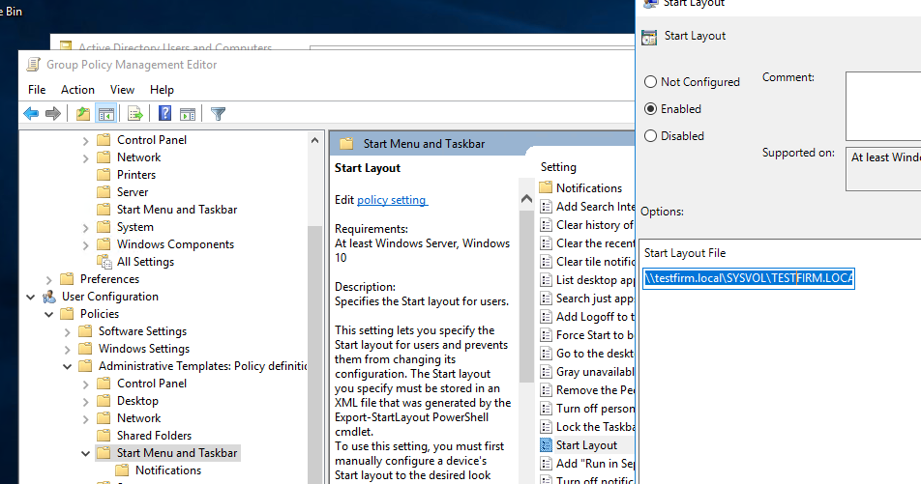

Now just link the GPO to an OU or the domain and log on with a user fo which it will be applied.

Regarding the GPO, 2 start layout xmls can be configured: one for PC and one

for USER and if a user that does not have the policy applied will get the PC policy.

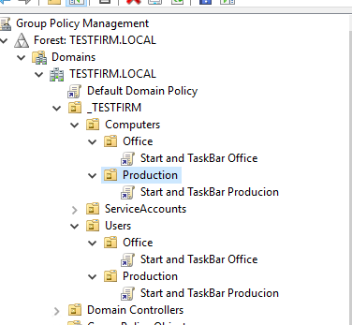

Everytime the start layout file is modified it will be reapplied and make the

taskbar changes again. A change is detected via the file timestamp.